Corrector: Aga
Number of movements: 2

1. A teacher gave out Smarties in class. Mike got two red and one purple, Tom got four orange, Kate got two blue and one red, Jo got one purple, three orange and three blue and Susie got four purple. Which colour was most common?

Corrector: Hayden
Number of movements: 2

2. In a test with two questions, six out of fourteen pupils answered both questions correctly and five got them both wrong. How many pupils answered exactly one question?

Corrector: Nikhil
Number of movements: 2

3. In 2008, Kate’s birthday was on a Tuesday. Her anniversary was 47 days later. On what day of the week did Kate celebrate her anniversary?

Corrector: Shruti
Number of movements: 2

4. There are two wooden boxes with flour in them. One is completely full and the other is exactly half full. One of them weighs 86 pounds and the other 53 pounds. What is the weight of an empty box?
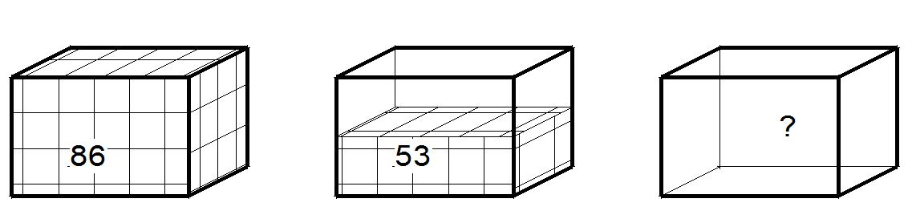

Corrector: Mary
Number of movements: 2

5. The clock in our kitchen runs late. Every hour, it is late by 10 minutes. This morning at 8:00 I set it to show the right time. At what time is it going to be exactly one and a half hours late?

Corrector: Aga
Number of movements: 2

6. Tom likes to send text messages from his mobile phone – he sends three every day. Every text costs 25p. After every 10 texts he can send 1 for free. How much will he pay in two weeks?

Corrector: Hayden
Number of movements: 2

7. Split the shape on the picture into three parts that have the same size and shape.
Corrector: Nikhil
Number of movements: 4

8. There are 252 people in the room. They split into groups of either two or five people. If we know, that the number of five people groups is the same as the number of two people groups, how many groups are there altogether?

Corrector: Shruti
Number of movements: 4

9. Mike went biking. He calculated that when his wheel spinns once he travels 120 cm. How many kilometres did he travel, if his wheel spun 20 000 times?
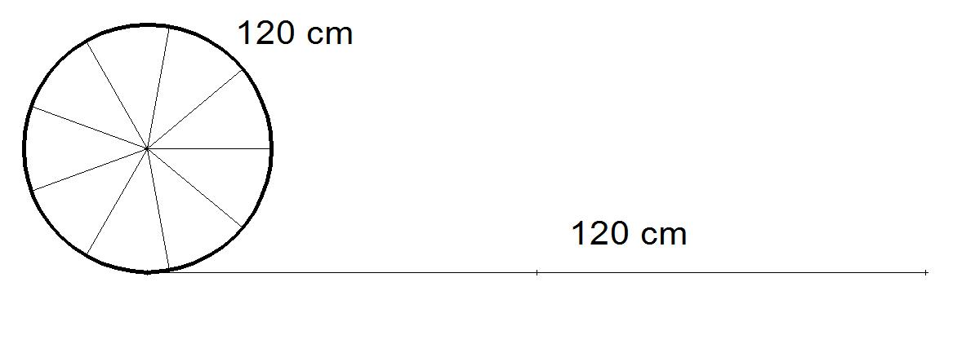

Corrector: Mary
Number of movements: 4

10. A table is of rectangular shape and three times as long as it is wide. If it were to be 3 metres shorter and 3 meters wider, it would be square. How big is the table?
Corrector: Aga
Number of movements: 4

11. The restaurant has two dining rooms. All the tables in both of the rooms have the same number of chairs around them. One of the rooms has a capacity of 66 people, the other 24 people. What is the biggest possible number of chairs around one table?

Corrector: Hayden
Number of movements: 4

12. The scout leader was trying to split the scouts into tents. If he would put 4 in each tent, he would have 2 scouts without a tent. If he would put 5 scouts in each tent, he would have 10 empty spaces. How many scouts are there?

Corrector: Nikhil
Number of movements: 4

13. I have painted a wooden cube red. Then I cut this cube 3 times each way, making 27 (3x3x3) smaller cubes. How many little cubes have one face painted red? How many have two?
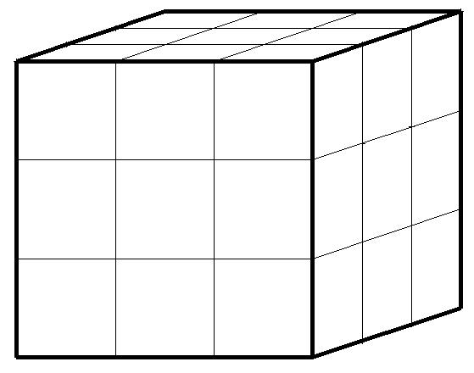
Corrector: Shruti
Number of movements: 4

14. Adam, Beth and Chris are three kids of different ages. We know that exactly one out of these claims is true:
1. Adam is the oldest one.
2. Beth is not the oldest one.
3. Chris is not the youngest one.
Who is the oldest and who is the youngest out of the children?

Corrector: Mary
Number of movements: 4

15. Two thirds of the people in the room are sitting, all the others are standing. There is someone sitting on three quarters of the chairs in the room. If we know that there are 6 empty chairs, how many people are in the room?

Corrector: Aga
Number of movements: 6

16. There are sheep and geese next to our house. Together, they have 64 legs. Given that there are twenty animals in total, how many geese and how many sheep are there?
Corrector: Hayden
Number of movements: 6

17. How can we measure 13cm using three sticks with lengths 10cm, 12cm and 15cm?
Hint: It is done by comparing the lengths of the sticks (we cannot cut the sticks).

10
12
15

Corrector: Nikhil
Number of movements: 6

18. Jo loves sweets. She ate 100 in five days. Every day (except the first one) she ate 6 more than the day before. How many did she eat the first day?

Corrector: Shruti
Number of movements: 6

19. Twenty years ago, my friend was three times younger than now. How old was he then?
Corrector: Mary
Number of movements: 6

20. A digital clock shows the time as 0:00, that means 0 hours, 0 minutes (they don’t show seconds). How much time does it take for them to display the number 2 twenty three-times? (If the clock says 2:22, it is displaying the number two three times.)

