- 1 -
Q8) [1] I have 7 boxes with the dimensions: 3ft×4ft×2ft, 7ft×1ft×1ft, 2ft×10ft×2ft, 3ft×3ft×12ft, 3ft×21ft×22ft, 13ft×14ft×12ft a 12ft×9ft×5ft. What is the highest tower I can build from them?
Q99) [1] In how many ways can you arrange 4 different books on a bookshelf?

Q69) [1] Martin has 1ft×1ft×1ft bricks. He is building a staircase like the one in the picture below. How many bricks does he need to build a staircase that is 10ft high?
5ft

Q64) [1] How many squares are there in this picture?

Q81) [1] What decimal number is illustrated?
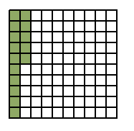

Q82) [1] Find the value of g. Write your answer as a decimal number
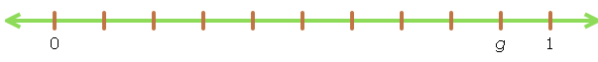
Q88) [1] The first train car, right behind the engine, contains 10 boxes. In each of the other cars there are twice as many boxes as in the car in front of it. How many boxes are there in the fifth car?
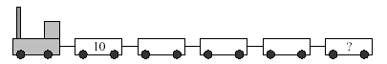

- 2 -
Q12) [2] We have 2 red and 2 blue cubes. We build a tower of a height of 4 cubes fromthem. How many different towers can we build?
Q89) [2] Which numbers are inside a rectangle and inside a circle but not inside a triangle at the same time?
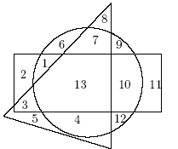

Q52) [2] How many integers are there between 2,09 and 15,3?

Q16) [2] A table is of rectangular shape and three times as long as it is wide. If it were to be 3 metres shorter and 3 meters wider, it would be square. How big is the table?
Q25) [2] Which set of fractions is ordered from least to greatest?
Q71) [2] Divide the object below into 4 tiles of the same shape and size.

Q66) [2] If it takes 1 second for a snail to move 5 mm, and it can only move on the solid black lines, how long would it take it to go from point A back to point A travelling through B, E, G, F and D?

Q29) [2] 4 cats eat 16 mice in 2 days. How many mice will 2 cats eat in one day?
Q75) [2] There are two wooden boxes with flour in them. One is completely full and the other is exactly half full. One of them weighs 86 pounds and the other 53 pounds. What is the weight of an empty box?
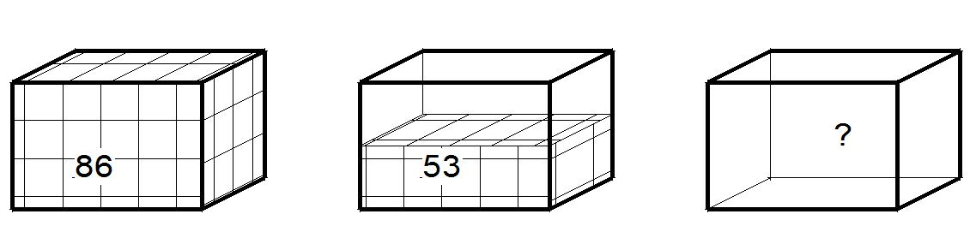

- 3 -
Q90) [3] John has a chocolate bar consisting of square pieces 1 cm x 1 cm in size. He has already eaten some of the corner pieces (see the picture). How many pieces does John have left?
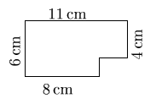
Q3) [3] How many 5s are there in the page numbers of a 100-page book?\
Q48) [3] Amanda chose a natural number and multiplied it by 3. Which of the following numbers cannot be the result of this operation?
A) 987 B) 444 | C) 204 | D) 105 | E) 103

Q46) [3] If 3×2006=2005+2007+a, then what is a equal to?

Q91) [3] How many tiles are needed to cover the inside of the heart completely, if one tile is the size of one square and you can cut the tiles.

Q92) [3] Put the numbers 1, 2, 3, 4, 5, 6, 7 and 8 in the bubbles so that each number’s neighbour is more than 1 away from it. For example: If you put 3 in one bubble, you cannot put 2 or 4 in any of the bubbles that connect to the 3.

Q70) [3] How many stickers in shape of small square do you need to cover the whole object below? (this object is a 3*3*3 cube with a one small cube sticking out of the middle of each side of the big cube)
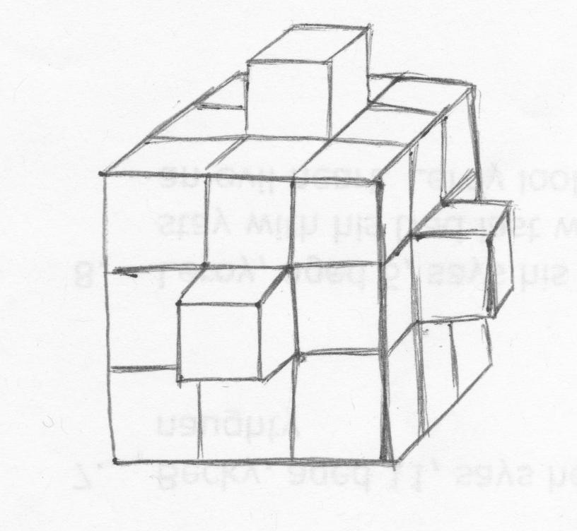

Q67) [3] What is the highest number you can get by starting with the number in the lower left corner and moving towards the upper right corner if you can ? You get the final number by adding or subtracting numbers as shown in the squares you pass through. In the example given, the final number is 3+1-3+3-2+2 = 4
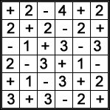

Q78) [3] Linda has an L-shaped house. She adds two rooms to it every year, as shown in the picture (one square is one room). If she continues like this, how many walls will her house have in 2020?
2007 2008 2009 2010

Q72) [3] What number is in the gray circle?
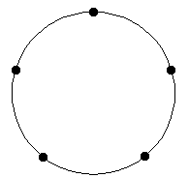
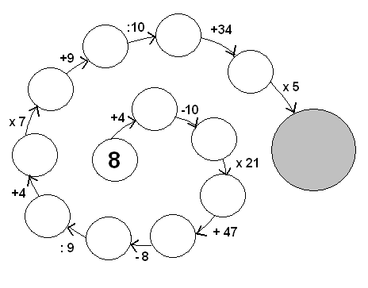
Q73) [3] How many triangles can we make by connecting the dots? Rotated triangles of the same shape are considered different.

Q74) [3] An amulet was built from white cubes 1x1x1 by creating a cube of size 3x3x3 and removing 3 'tunnels' from the middle (see picture). 7 cubes were removed by this. This whole amulet was then painted red. How many cubes have an even number of red sides?

Q77) [3] How can we measure 13cm using three sticks with lengths 10cm, 12cm and 15cm? We cannot cut sticks.

10
12
15

Q80) [3] Below you can see what digits made of matches look like.
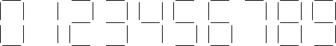

By moving only two matches in 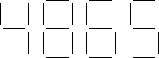 , create the biggest possibile natural number.

Q85) [3] In how many ways one can shade 4 squares below, so that in each row only one square is shaded?
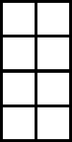
Q86) [3] From a square puzzle, two pieces, which made up the shaded region, were cut out (see the figure). Which two of the pieces below are these?
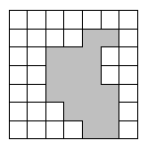
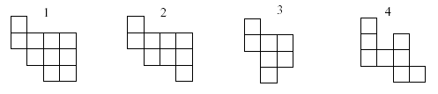
Q87) [3] Which of the figures below (see the picture) couldn't be made with folding a rectangular sheet just once?

A) 
B) 
C) 
D) 
E) 
Q83) [3] How much will it cost to buy 100g of bittersweet chocolate and 250g of semisweet chocolate?
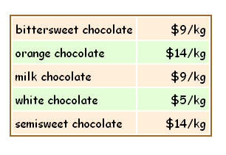
Q43) [3] A cube with side length of 1 meter was cut into cubes of side length of 1 decimeter. If we placed all smaller cubes on top of one another, how tall would the construction be?

Q68) [3] Exactly one of the signs is true and two are false. Where is the treasure?
The treasure is in this box
The treasure is not in this box
The treasure is not in the grey box

- 4 -
Q95) [4] Why are some letters above the line and some below?

A E F H I K L M N T V W X Y Z
B C D G J O P Q R S U
Q30) [4] Which number does not fit in the sequence?
5 4 10 9 12 14 20 19 25 24 30 29

Q65) [4] Draw this picture without lifting your pen off the paper or tracing over any lines.

Q76) [4] Mike went biking. He calculated that when his wheel spinns once he travels 120 cm. How many kilometres did he travel, if his wheel spun 20 000 times?
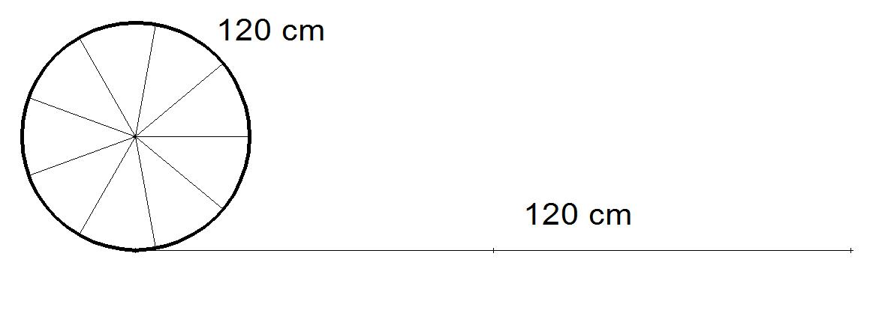

How can we measure 13cm using three sticks with lengths 10cm, 12cm and 15cm?
Q41) [4] In two years Adam is going to be twice as old as he was two years ago. In three years Dorothy is going to be three times as old as she was three years ago. Which of the following sentences is true?
- Adam is a year older than Dorothy.
- Dorothy is a year older than Adam.
- There is no age difference between the two.
- Adam is two years older than Dorothy.
- Dorothy is two years older than Adam.

Q31) [4] Tom has got 40 matches. Mark took some matches and formed a triangle. The length of each side of the triangle is 2 matches. Tom took the remaining matches and formed a rectangle. One side of a rectangle has the length of 2 matches. What is the length of the other side of the rectangle?

- 5 -
Q44) [5] Michael made up a natural number. Jacob multiplied it by one of the two numbers: either 5 or 6. Then Joel added either 5 or 6 to the number and finally, Adam subtracted either 5 or 6. The result after all operations was 73. With what number did Michael start the game?

Q79) [5] Identical little drawings on this cube represent the beginnings and ends of paths made of steps from square to square. Steps can only be made on the surface and to a square that shares a whole side with the one you’re on (a corner is not enough!). Connect all the drawings so that the paths between them do not cross at any point.

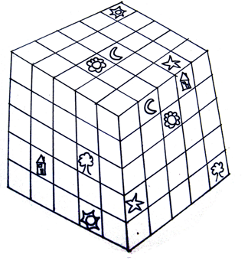

Q98) [5] If you write numbers in order next to each other (123456789101112131415...) which digit will be on the 1000th place?
Q84) [5] The size of the biggest square is equal to 16 cm². The size of the smallest square is 4 cm². What’s the size of the middle sized square?
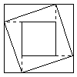

Q60) [5] One of the sides of a rectangle was enlarged by 10%. The other side was shortened by 10%, By how many percent did the area of the rectangle change?
Q54) [5] Imagine we have 6 segments of length: 1, 2, 3, 2001, 2002, 2003. In how many ways can we choose three segments that could form a triangle?

